System Security

Assignment on SSH

Praneesh R V

CB.SC.U4CYS23036

1, Login as root user

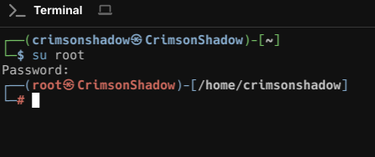

2, Create two users yourrollnumberamrita(client)(last 10 characters) and yourrollnumbercoimbatore(server) (cb.sc.’….’) with passwords.

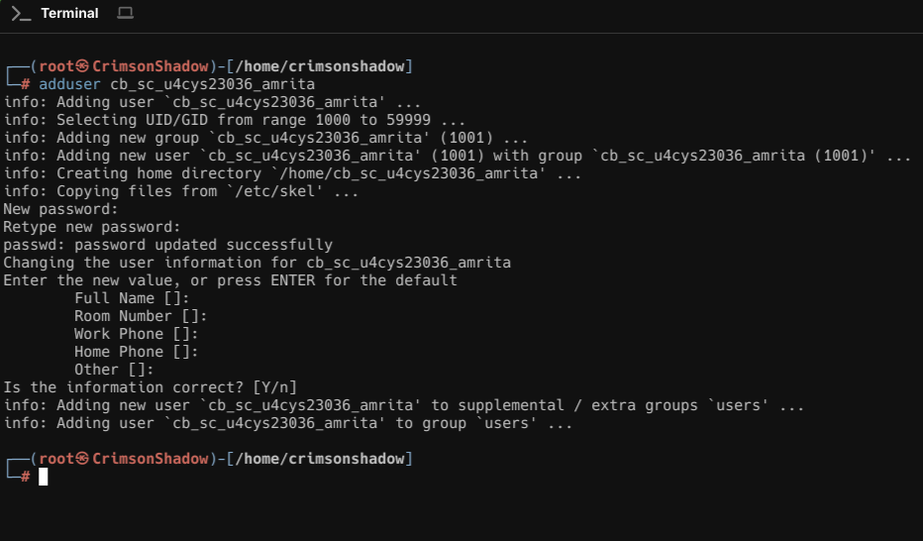

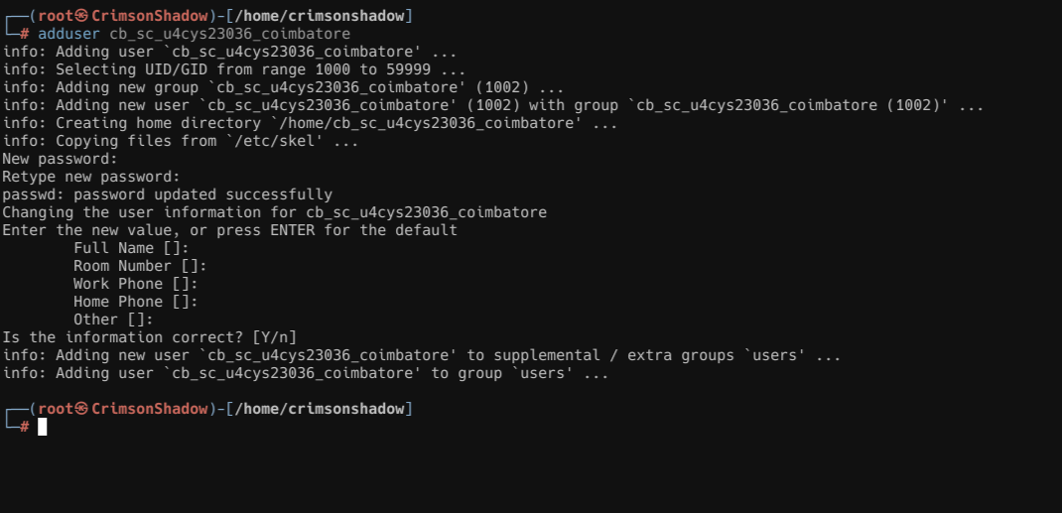

3, Login as yourrollnumberamrita. Use ssh to create the private and public ids at the location /home/yourrollnumberamrita/.ssh

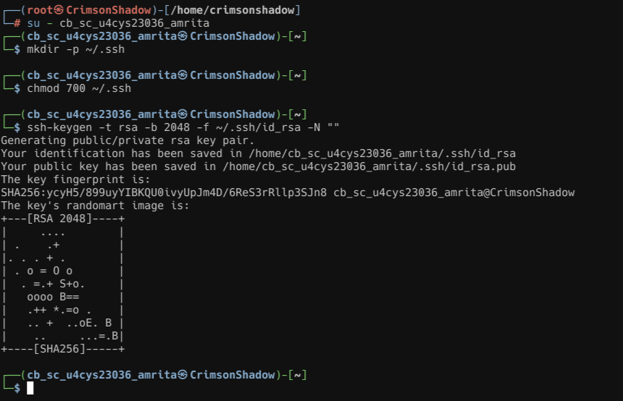

4, Then copy the public id file to the /home/yourrollnumbercoimbatore/.ssh/authorized_keys

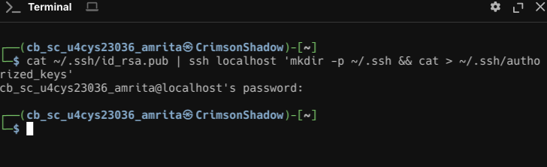

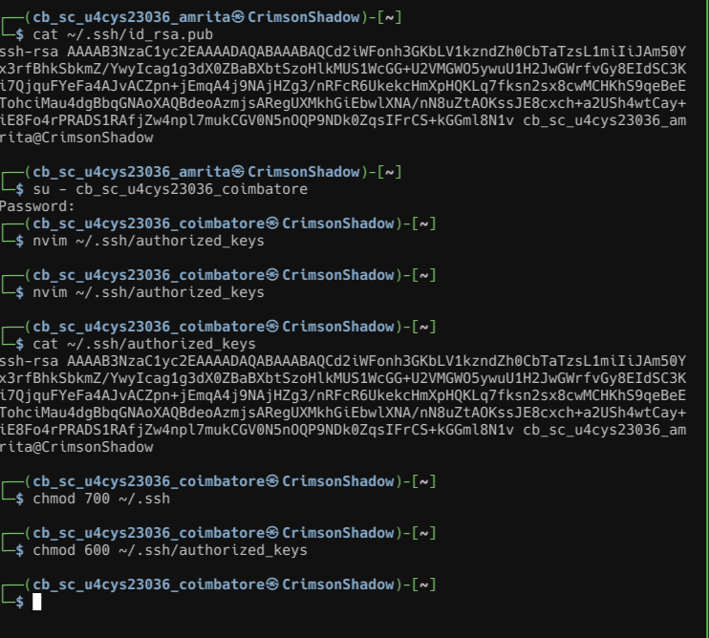

5, Do the necessary steps if required (editing ssh config files and restarting the service, providing permissions for .ssh and .ssh/ authorized_keys etc..)

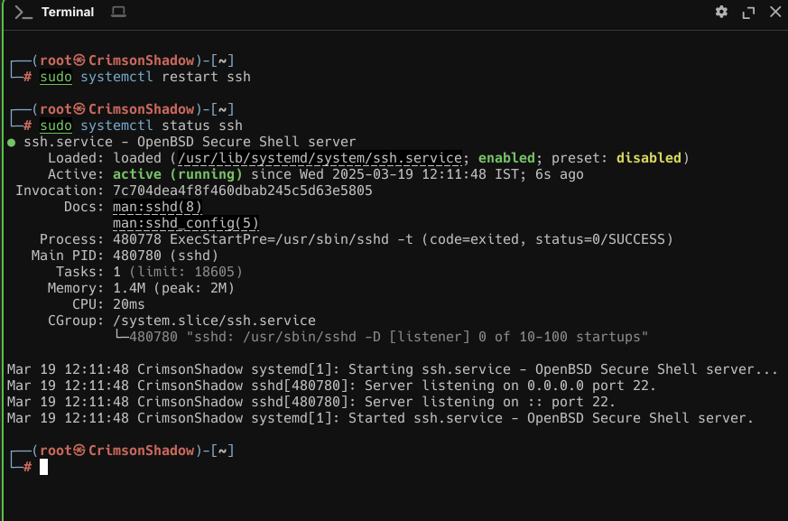

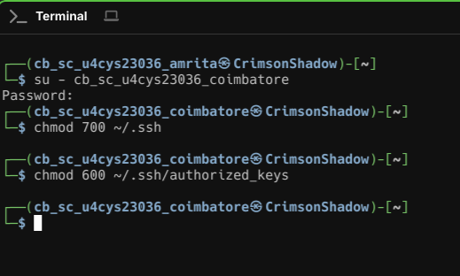

6, Check are you able to login without a password from yourrollnumberamrita to yourrollnumbercoimbatore using ssh

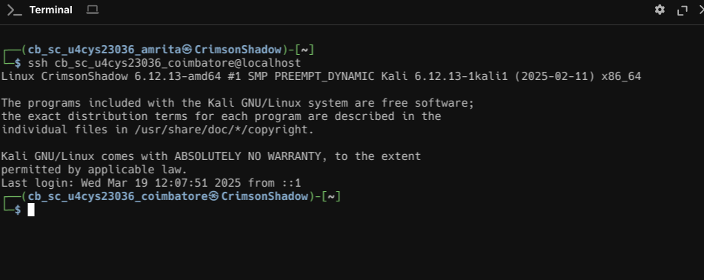

SSH connected without Password